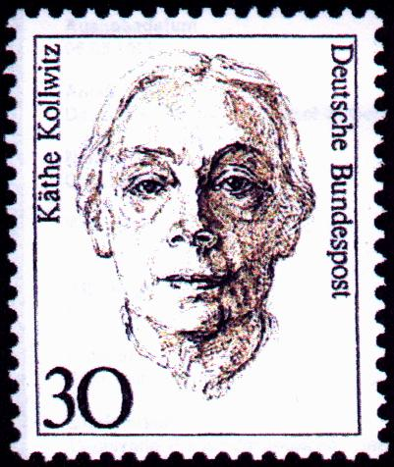
Name: _______________________________ Date: _________ Period: _______
KATHE KOLLWITZ : Mono-Print Making Written Assignment
Purpose: You will assess the impact of current events on the artist, Kathe Kollwitz. You will identify the factors that interfered with her goals. Additionally, you will become familiar with her most famous works of art.
Task:
- Identify the following key terms that should find their way into your project:
  - German Peasant’s War
  - WWI
  - Reformation
  - Expressionism
  - Impressionism
  - Communism
  - Nationalist-Socialist Regime
  - Gestapo
  - Evacuated
  - Berlin Wall

- Create a time line of Kollwitz’s life. Identify major historical events that occurred during her life time. Consider the locations she lived in. (If she lived in Prussia, do not write down all historical events that happened in Nigeria). Note: Prussia no longer exists.
  - Google timeline, readwrite think

- Collect images of Kollowitz’s artwork in a computer file. Moma.org is a great site (google Kollowitz, moma.org
  - Analyze the dates of the prints to see where the dates of production would fit into your timeline.
    - Right Click
    - Click Save image as
    - Create a new file under your documents labeled Kathe Kollowitz
    - LABEL WITH YEAR AND NAME OF ARTWORK EX: 1897 Revolt (by the gates of a park)
  - Insert Images into timeline on readwritethink’s timeline website. On each timeline attach one image and briefly explain how she was influenced by the current events.
    - Each Historical event should have an image that relates to it placed on the opposite side of the timeline as the artist images. (you may google images)
- Save file under Kathe Kollowitz’s file on your documents. Share your document with me by either emailing it to me at jpeachee@wcs.k12.in.us or “sharing” your google document with me.
  - Print out a hard copy when in the computer lab.

