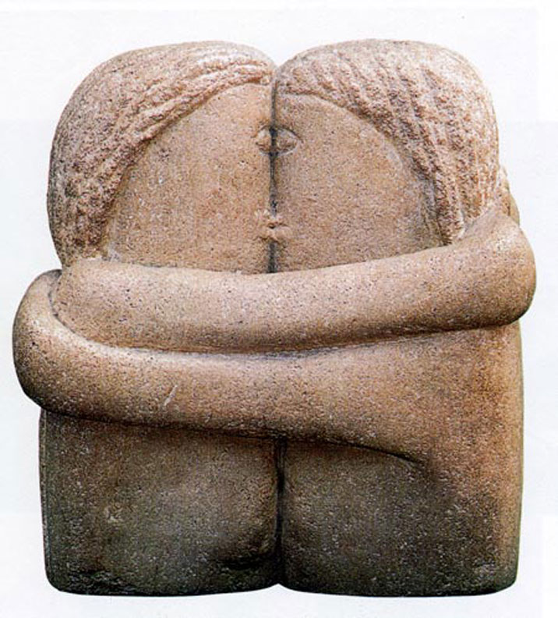
The Kiss by Constantin Brancusi (1876-1957)

Using the following link summarize the psychological response to Brancusi’s by Victor (Yes no last name automatically should lead you to question validity of an author remaining somewhat anonymous; however, an interesting read and provides excellent insight in how you can analyze art).

Do you agree or disagree with Victor’s views?

Provide your own perspective into a piece of artwork. Your choice on the artwork. Break it down and analyze both with your elements/principles and with a psychological approach.

