A Brief and General History of the Face Jug

When you look at the images of the Ugly jugs what cultures come to mind to you? (review images at the end and what group of people come to mind?)

What group of islands did African Slaves pass through before entering the United States? (Highlight your evidence from the text yellow)

What is a key reason why many slaves would be drawn to expressive face jugs when living on plantations?(underline your evidence from the text)

Think about it!

By

Karl Kuehn

Face jug history is surrounded in mystery. Stories vary about who created face jugs and the reasons for their creation range from the 1700s to the present.

**One version is that an unknown potter in Massachusetts created the first face jug in or around 1810.** This is inconsistent with the theory that face jugs originated with African slaves who worked on American plantations**.  A great many slaves brought to the United States were processed in the Caribbean where they acquired a belief in Voodoo.** The exposure to Voodoo, along with their own beliefs brought with them from Africa and the introduction to Christianity must have created extraordinary confusion to people from an entirely different culture.

Jug shards have been found on grave sites and along underground railroads. This might imply that the face jugs were very important to the escaping slaves**.  Speculation is that slaves who were not allowed to have tomb stones. So they developed face jugs as grave markers designed to scare and keep the devil away.**

**In the 1800's, many people were becoming ill and dying from the lead glazes used to seal the low-fire pottery that was being used by the settlers of the southern USA. In response, Dr. Abner Landrum founded Pottersville, a group of about 16 or 17 houses with families in the area within 1.5 miles from the Edgefield court house in South Carolina (now Aiken County). It grew into a village of about 150 people, mostly slaves.** David Drake is the most notable. They produced lead-free pottery and face jugs until the beginning of civil war. This pottery is now known as Edgefield Pottery. It is the only form of pottery that was made entirely by American tradition. Alkaline glazed stoneware was a re-discovery by Dr.Landrum

What was the significance of Pottersville? (underline your evidence from the text.)

What impact did the Civil war have on Pottersville? Their Pottery?(highlight your evidence from the text yellow)

Explain the evolution of the Face Jug to the Ugly jug.(circle your evidence from the text)

Think about it!

and his two brothers. (It originated from the Han Dynasty in China over 2000 years ago.) When the civil war started in 1861 Pottersville was abandoned but alkaline glazed pottery continued to be produced in the south. The picture above is from an Edgefield excavation. (Courtesy of Gary Dexter)

**In the 1820's the practice of making face jugs spread throughout South Carolina and into Georgia, North Carolina and other states.** In the 1830s about seventy folk potters operated pottery shops within a four mile area of Mossy Creek in White County, Georgia. This became one of the largest pottery communities in the South. Names like Dorsey, Meaders, Craven, Davidson, Pitchford, Brownlow, Warwick, Chandler and Anderson became known, at that time, for their pottery.

**The purpose of the jug evolved. The face jug also became known as the ugly jug in the 1920's and was used to store alcohol. The jugs became uglier in an attempt to identify the contents and frighten children**. Parents warned the youngsters to stay away from them.Many of the early pieces were small in scale, from 4 to 4 and a half inches. They were thrown on the wheel in the harvest jug style where there is an overhead strap handle on the body of the pot off set with one or more spouts. Teeth and eyes were made from white kaolin clay to contrast the darker color of the stoneware clay. **These early pieces were glazed with alkaline glazes and fired in large wood burning kilns along with the potter’s functional ware.**

**In the early part of the 19th century the form was adopted by white potters. This can be attributed to the downturn in profit for the white potters from the everyday items such as churns and storage jars.** **This was probably due to the major influx of cheaper mass produced ware being imported from the northern factories.** **To avoid going out of business the potters started making unique items such as miniatures and face jugs.** These items helped to keep the potters from closing down since they appealed to the tourist trade.

There has been a continuum in the interest of face jugs throughout the 20th century primarily centered on two prominent potters, Burlon Craig and Lanier Meaders. However it wasn't until the 1970's when there was an upscale interest in American Folk lore by university academics that the work of Craig and Meaders were exposed to a larger American audience. The popularity of these two potters surged and the face jug as an art form along with interest in its history experienced a renaissance.

**Lanier Meaders (1917-1998) is the most famous Georgia folk potter who made face jugs. The Meaders family was famous in Georgia for their stoneware pottery.** Lanier was the face jug maker who kept folk art pottery alive in the south almost on his own!

Why do you believe the face jug has survived as long as it has? (Highlight evidence from the text in orange.)

Think about it!

Today, a few family-operated potteries are still making face jugs in the traditional way. They start with the local clay and fire their work in a wood-burning kiln. The traditional way of making a face jug would often incorporate the use of porcelain teeth and eyes. At the end of a long the day of production, scrap clay is frequently used to make face jugs just for fun.

Recently, quite a few independent potters living throughout the world have taken up the art of making face jugs, Some of these face jugs are crafted in a traditional fashion while other potters are creating far out, highly complex and unique face jugs using a variety of firing techniques.

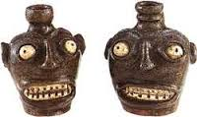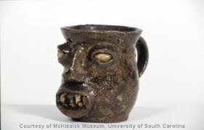 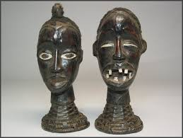

**Answer the following Questions from information above:**

1. Where did ugly jugs first appear in history? ________________________________________________________________________________________________________________________________

2. Who made the ugly jugs in the 1800s? ________________________________________________________________

3. According to history and folk lore, what were some of the reasons that these jugs were created? ________________________________________________ ________________________________________________________________________________________________________________________________________________________________________________________________________________________________________________________________

4. What kind of clay and finish were these jugs usually created in during the 1800s? _________________________________________________________

________________________________________________________________________________________________________________________________

________________________________________________________________

5. Who started to make the ugly jugs or mugs in the 1900s? Why did they start making them? ________________________________________________________________________________________________________________________________________________________________________________________________________________________________________________________________

_____________________________________________________________

6. Why was there a revived interest in these ugly jugs in the 1970s? What two potters was this revival centered upon? ________________________________________________________________________________________________________________________________________________________________________________________________________________________________________________________________

__________________________________________________________________________________________________________________________

History by: [Robin Gianis](mailto:RGianis@bridgehampton.k12.ny.us), Art Teacher, K-12 - Bridgehampton School, NY, Virginia Scotchie http://www.carolinaarts.com/204so.pottery.html, Karen Sue Dill, Art Teacher K-12, North White SC.

UGLY JUGS AND MUGS CLAY PROJECT

**Objectives:**

**1**. **History**: H.1.1-Identify and analyze the relationship between a work or art and the history, geography, technology of the culture, and identify where, when why and by whom the work was made. **.**

H.1.2-Identify function in artwork and how it relates to the history, aesthetics and culture of a work.

H.2.2-Identify stylistic characteristics in the works of art and artifacts across time and among cultural groups to analyze and identify influences**. Do all of the above by reading the history and identifying the relationships on the worksheet thoughtfully**

**2. Integrated Studies**: H.8.1-Analyze characteristics of visual arts within a particular historical period or style with similar ideas, issues, or themes in other disciplines and demonstrate enhanced understandings of the historical period. H.8.2-Create works that communicate in-depth knowledge gained through the experience of integrated study**. Draw 4 thumbnail sketches of your own ugly mug or jug after learning the history of these vessels. Then describe in written notations on your sketches what method of construction you will use and how you will finish the vessel. Also write in your notes how you would envision your vessel being used.**

**3. Creating Art**: H.6.1-Demonstrate skill in perception from real life to present convincing, accurately rendered objects from real life. **Create your head with proper facial proportions and expression.**

**4.** H.6.4-Demonstrate thoughtful revision and refinement of original work based upon reflection, critique, practice, and research. **Take the time to do the preliminary work, sketches and research. Create, re-evaluate/reflect/ask for advice/refine your piece-- make it better even after you think you are done.**

**5.** H.7.2 Create works of art that use specific principles to solve visual problems. **(Balance, Movement, Proportion and Unity)**

**6.** H.7.3-Create artworks that demonstrate skill and understanding of different media, processes, and techniques. **Use the best clay techniques and finish with the medium that best suits your creation**

**7.** **Criticism and Aesthetics**: H.4.4-**Engage in critical reading, writing, and discourse to improve understanding of own work and that of others by reading the history of Ugly Jugs and giving thoughtful answers as well as writing thoughtful evaluation responses on your evaluation rubric when project is complete.**

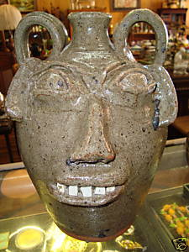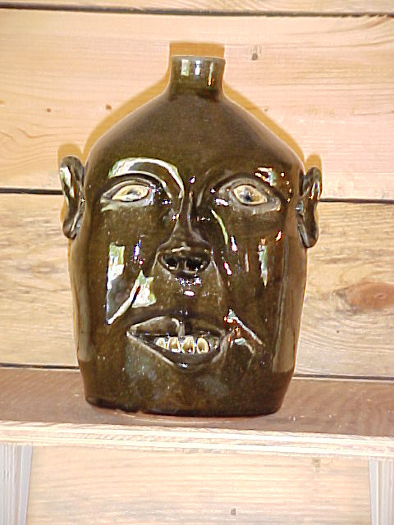

Burlon Craig’s Face Vessel Lanier Meaders’ Face Vessel

More Ugly Jug and Mug Examples: http://www.visitsoutherncomfort.com/potfacjugand.html

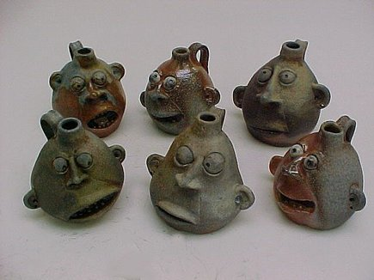        [**Click here for more info from Gary Dexter**](http://www.kuehnpottery.com/Edgefield%20pottery%20and%20me1.pdf)

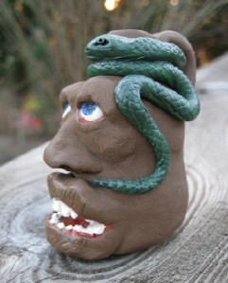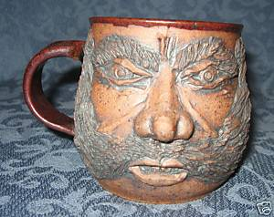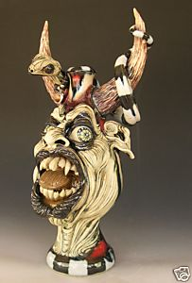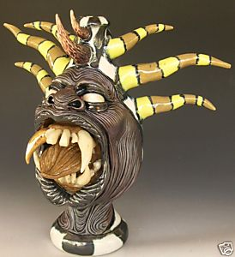

|  |  |  |  |  |  |  |  |
| --- | --- | --- | --- | --- | --- | --- | --- |
| **Final Advanced Ceramics Assessment Rubric** | | | | | | | |
| **Student Name:** | | | | | **Class Period:** | |
| Assignment: **Ugly Mug or Jug** | | | | | **Date Completed:** | |
| Circle the number **in pencil** that best shows how well you feel that you completed that criterion for the assignment. | **Excellent** | **Good** | **Average** | **Needs Improvement** | **Rate Yourself** | **Teacher’s Rating** |
| **Criteria 1** – Researching ideas, completing reading and worksheet, Planning sketches - developing ideas. Idea was well thought out and had an interesting face with expression. | 5 | 4 | 3 | 2 |  |  |
| **Criteria 2** – Forming the Ugly Mug or Jug – Did you choose the best method of construction for the idea? Was your clay worked up completely before beginning construction? Was the mug or jug well-constructed on all sides and the walls less than ½ an inch thick? Was the bottom of container smooth and level? Were the details crisp and clear? Were the features well proportioned? Did the face have all of its features? Did the face have an interesting/creative expression? Did the overall piece have no cracks? Were the edges/curves smooth and straight, inside and out? If the container had handles or pieces added were they securely attached by scoring and slipping with water, vinegar, or slip and did not fall off? Did your piece blow up in the kiln or loose pieces? | 5 | 4 | 3 | 2 |  |  |
| **Criteria 3** –finishing the piece after firing. Did you finish your piece by painting with acrylics, shoe polish, or glazes? If you painted was it neatly done with no unpainted areas? Was the piece finished inside and out? If you glazed, did you used three coats of glaze inside and out? Did you make good color choices that enhanced the beauty and meaning of your mug or jug? Did you keep glaze brushes separate and clean? | 5 | 4 | 3 | 2 |  |  |
| **Criteria 4** – **Effort**: did you take **time** to develop your idea & complete your project? Did you make revisions as you worked to improve your idea? Did make sure your clay piece was crack free and smooth inside, on top, and underneath? Did you make good use of class time? Did you add more details and definition after the clay piece was in the leather hard stage? Did you take care in the finishing process when applying paint or glaze? | 5 | 4 | 3 | 2 |  |  |
| **Criteria 5- Directions –** Did you follow instructions on completing the worksheet, pre-planning and construction of the ugly mug or jug and procedures for working up clay, cleaning up area, returning tools, and clay cloths, cups, cleaning/storing of brushes, glazes and paint to proper places? Did you complete this evaluation with well thought out answers to the questions below? | 5 | 4 | 3 | 2 |  |  |
| **Criteria 6- S** |  |  |  |  |  |  |
| **Total Possible: 25** |  |  |  |  | **YOUR TOTAL** | Grade |

5: Pushed the limit of your skill set and branched out.

4: Met your skill set fulfilling all requirements

3: Did not meet your skill set, but met all the requirements

2: Did not meet your skills set, met most of the requirements

**Comments:**