Name: ___________________________ Date: __________ Period: ______
South West Indians:
Four major styles of Southwest Indian Pottery:

1.
2.
3.
4.

Describe the Anasazi pottery style:

Artist/Group | Lucy Lewis | Maria Martinez | Nampeyo | Tafoya
Date Range
Location
Style inspired from?
What is iconic about the pottery?
- Select one of the artist: __________________________________
- Create a mini poster 4x6
  - Recommend you use power point
  - Click “view” to place the ruler on your screen so you can tell your size
  - You can use word and adjust your page size to be 4x6 as well
  - You will cut out your poster for display with you piece.
- Identify all of the information above
- Add images of their pottery (minimum of 3 pieces)
- Add a small image of the artist
- Include your name
- Include MLA citation at the bottom of your mini poster (use citation machine if needed)
- One computer lab day will be given. Use the in-class computer to work ahead so all you have to do is print and adjust when we get into the computer lab
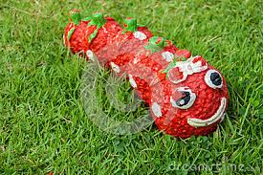
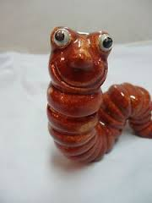
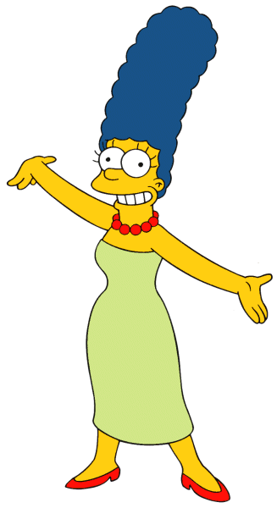
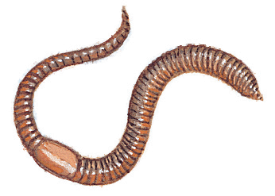
Example:
Artist Name
By: Mrs. Peachee

Pueblo Potter, Jane Doe, is famous for her works with earthworms in clay. The organic matter creates an interesting pattern that is reminiscent of her ancestors the Anasazi Indians (Joking, 2015)

Joking, John. (2015) www.anasazi spoof.com
You will be graded on…
WRITTEN COMPONENT:
- Are all required components from this handout present?
- Did you follow the guidelines?
- Did you show initiative? (Did you take it seriously?)
- Is it turned in on time
- Is it printed
- Is it cut out ready for display
PROJECT:
- Coils hold together well
- Shape is strong
- Coils are of adequate size
- Piece is reminiscent of your artists style with your own flare
- Piece is dried properly
- Piece is painted properly
- Piece is submitted on time
- Time is used appropriately
- Coil discs are smoothed except where open coils were the desired effect.

